MEHRAN UNIVERSITY

OF ENGINEERING & TECHNOLOGY

JAMSHORO, PAKISTAN

To understand how router works and basic configuration of router using console connection.

Subject: COMPUTER NETWORKS (PR)

(Lab 6 - Tasks Solution)

|  |  |
| --- | --- |
| **Roll No:** | **22SW028** |
| **Section:** | **I** |

**LAB TASKS:**

**Answers to Questions:**

**1.** **Why have we assigned an IP address of which class and how many host IP addresses does it have?**

Ans: The IP addresses are from Class C, with a subnet mask of 255.255.255.0. This allows up to 254 usable IP addresses per network (192.168.1.1 - 192.168.1.254, etc.).

**2. Why have the hosts been assigned default gateway addresses?**

Ans: The default gateway is required for PCs to communicate with devices on other networks. Each PC uses the router interface connected to its network as a gateway to communicate with other PCs on different networks.

LAB TASK:

I. Connect three pcs with router using crossover cable

II. Configure router interfaces with three different networks using class C IP address scheme.

SOLUTION:

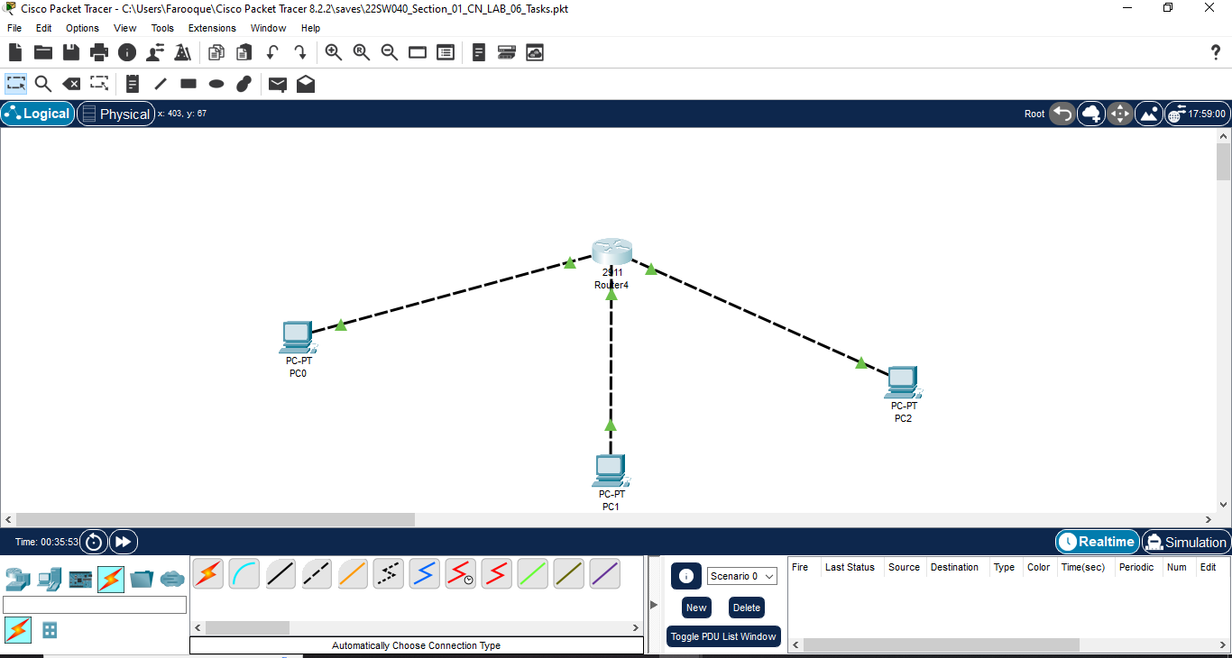

The following network was made ensuring that all Pc’s are given Class C IP

addresses and configured the router with all 3 interfaces.

VERIFYING CONNECTIVITY:

